SWIGGY FUNNEL ANALYSIS



**Introduction**

This case study focuses on analysing Swiggy's performance in 2019. With over a million daily transactions, Swiggy has become a dominant force in the industry. The Growth and Strategy Analyst, armed with data from the 'Funnel Case Study,' aims to unveil insights using sheets like Session Details, Channel-wise Traffic, and Supporting Data. Through rigorous analysis, the study seeks to uncover trends in order dynamics, changes in traffic, and shifts in overall conversion rates. Employing frameworks like AARRR, the goal is to provide actionable insights that can shape Swiggy's strategic direction in this rapidly evolving market.

**Data Overview**

The 'Swiggy Funnel Analysis' workbook encompasses three key sheets, each contributing valuable insights into Swiggy's performance during 2019.

1. Session Details Sheet

The Session Details sheet offers a day-to-day breakdown of user interactions on the Swiggy platform. Key metrics include:

* Listing Sessions: Sources of traffic from where the customers are viewing the restaurants.
* Menu Sessions: Sessions involving the exploration of restaurant menus.
* Cart Sessions: Instances where users add items to their carts.
* Payment Sessions: Sessions initiated for payment processing.
* Order Sessions: Sessions resulting in successful order placement.

These metrics provide a granular view of the user journey, from initial engagement to transaction completion.

2. Channel-wise Traffic Sheet

The Channel-wise Traffic sheet delves into the specifics of traffic generation on Swiggy, particularly focused on listing sessions. This sheet breaks down listing sessions at the date

level, allowing for a nuanced understanding of the sources contributing to Swiggy's traffic. The various traffic sources are Facebook, YouTube, Twitter and Others.

3. Supporting Data Sheet

The Supporting Data sheet encompasses various additional metrics at the date level, offering a more comprehensive view of Swiggy's operational landscape. Key metrics include:

* Count of Restaurants: Reflecting the number of operating restaurants for the day.
* Average Discount: Providing insights into the average discount offered to transacting customers.
* Out of Stock Items per Restaurant: Indicating the average number of out-of-stock items per restaurant.
* Avg. Packaging Charges: The average packaging charges paid by customers during order placement.
* Avg. Delivery Charges: The average delivery charges incurred by customers.
* Avg. Cost for Two: An approximate spent for creating a meal for two.
* Number of Images per Restaurant: Count of images listed per restaurant on the menu page.
* Success Rate of Payments: Representing the ratio of successful transactions to payment initiations.

These supplementary metrics serve to contextualize the operational aspects influencing Swiggy's performance.

In the subsequent sections, we will leverage the insights gleaned from these sheets to conduct a comprehensive analysis of Swiggy's growth and strategic landscape in 2019.

**Insights** (Based on tasks mentioned in swiggy’s funnel business case pdf)

1. Remaining columns of session details

* Calculated overall conversion using formula (order/listing).
* Calculated order change using formula ((order of current date/orders of same day last week) -1)
* Calculated traffic change using formula ((traffic of current date/traffic of same day last week) -1)
* Calculated conversion change using formula ((overall conversion of current date/overall conversion of same day last week) -1)

2. Dates of hike and drop in orders with respect to same day last week.

|  |  |
| --- | --- |
| **Dates of Hike in orders with reason** | **Dates of Drop in orders with reason** |
| **17-01-2019** – When compared to same day last week (10-01-2019) there is change in 151%. There is comparatively increase in number of traffic with a traffic change % of 220%. | **10-01-2019** – Reasons are due to significant decrease in traffic numbers and significant increase in average cost for two. |
| **05-02-2019** - When compared to same day last week (29-01-2019) there is change in 187%. Reason for this change is not due to change in traffic as numbers are almost same. But possible reason is due to count of restaurants which has doubled. | **29-01-2019** – Reasons are due to decrease in traffic numbers & decrease in count of restaurants. |
| **26-02-2019** – When compared to same day last week (19-02-2019) there is 176% change. Reason for this change is not due to change in traffic as numbers are almost same. But possible reasons are out of stock items per restaurants decreased, average packaging charges & average delivery charges have decreased. | **19-02-2019** – There is significant decrease in order%. Also, change in 6% of reduction in traffic. |
| **09-03-2019** – When compared to same day last week (02-03-2019) there is 140% change. When we see the channel wise traffic, there is no change in it. Reason might be due to “out of stock items per restaurant” is less and “average delivery charges” have surged down. | **02-03-2019** – Reasons are due to increase in average delivery charges & increase in out-of-stock items. |
| **11-04-2019** – When compared to same day last week (04-04-2019) there is 144% change. Average discount price has surged down and this is the possible reason. | **19-03-2019** – There is huge decrease in order% change when compared to same day last week. Reasons are due to decrease in number of images per restaurants and less availability of restaurants. |
| **27-06-2019** – When compared to same day last week (20-06-2019) there is 169% change. Reason for this is due to increase in number of all the traffic sources. | **04-04-2019** – There is significant change in 46% when compared to same day last week. And possible reason is due to decrease in average discount. |
| **23-07-2019** – When compared to same day last week (16-07-2019) there is 198% change. Reasons for this is due to decrease in out-of-stock items per restaurant and also decrease in average delivery charges. | **25-04-2019** – There is huge difference in order% when compared to same day last week i.e., 112%. Reasons are due to increase in average cost for two and decrease in average discount. |
| **18-08-2019** – When compared to same day last week (11-08-2019) there is 161% change. Reasons for this is due to decrease in average packaging charges. | **20-06-2019** – There is significant change in order% of -45%. And significant or huge decrease in total traffic. Reasons are due to less availability of restaurants. |
| **21-09-2019** – When compared to same day last week (14-09-2019) there is 166% change. Reasons for this is due to less number of out-of-stock items per restaurant and drop in average prices of delivery & packaging charges. | **16-07-2019** - There is significant change in order% of -60%. Reasons is due to 14% reduction in traffic and also 3rs hike in delivery charges. |
| **24-11-2019** – When compared to same day last week (17-11-2019) there is 192% change. Reasons for this is due to significant increase in traffic % & reduced number of out of stocks items per restaurants. | **11-08-2019** – There is difference of -53% change in order% when compared to same day last week. Reasons are due to hike in average packaging & cost for two. |
|  | **14-09-2019** – Major reason is out of stock items per restaurant are more when compared to same day last week. |
|  | **17-11-2019** – Reasons are due to decrease in traffic% when compared to same day last week. And major reason is due to out-of-stock items per restaurant has increased drastically. |

**Fig 1: Order conversion with respect to same day last week.**

3. Dates with change in traffic with source of traffic with reason

|  |  |  |  |
| --- | --- | --- | --- |
| **Dates with Hike** | **Reason** | **Dates with Drop** | **Reason** |
| 17-01-2019 | when compared to same day last week (10-01-2019), there is hike in numbers of traffic. There is 159% hike in it. This may be due to factors like promotional campaigns, new restaurant additions, or some events. | 10-01-2019 | Reasons for drop in traffic might be due to inclement weather or bad marketing campaign. |
| 22-01-2019 | when compared to same day last week (15-01-2019), there is hike in numbers of traffic. There is 79% hike in it. This is due to hike in Facebook and twitter traffic. Reason might be more active Facebook and twitter users encountering with swiggy ads or posts, which eventually leads them to the app. | 29-01-2019 | Reasons for drop in traffic might be due to pricing changes or customer choosing to dine-in. |
| 27-06-2019 | when compared to same day last week (20-06-2019), there is hike in numbers of traffic. There is 182% hike in it. Eventually, there is hike in all the four sources and possible reasons being new menu offerings, marketing campaign launch or new features on the swiggy app. | 20-06-2019 | Reasons for drop in traffic might be due to competing events on different food platforms or swiggy app outage. |

**Fig 2: Traffic change with respect to same day last week**

4. Broke the overall conversion into smaller part in the following metrics using particular formula.

* L2M – (menu/listing)
* M2C – (cart/menu)
* C2P – (payment/cart)
* P2O – (order/payment)

5. Identified dates with fluctuating/sudden hike or drop as compared to previous dates with conversion which is impacting and formed hypothesis around them.

|  |  |  |
| --- | --- | --- |
| **Hikes** | | |
| **Dates** | **Conversion Impacting** | **Reasons** |
| 05-02-2019 | L2M | The slight increase in the number of images per restaurant and the decrease in out-of-stock items per restaurant may be positively influencing the L2M conversion. Customers could be more enticed to explore menus with increased visual content, and a lower likelihood of out-of-stock items might encourage users to transition from Listing to Menu sessions. |
| 26-02-2019 | C2P | The higher number of images per restaurant, coupled with a decrease in average cost for two and average packaging charges, could be positively impacting the C2P conversion. Enhanced visual content may contribute to a more appealing user experience, and reduced costs may encourage users to proceed from Cart to Payment. |
| 11-04-2019 | C2P | The slight decrease in average packaging charges and the increase in the number of images per restaurant might be positively influencing the C2P conversion. A more cost-effective proposition and improved visual representation could contribute to a higher transition rate from Cart to Payment. |
| 23-07-2019 | C2P | The slight decrease in average delivery charges and the slight increase in the number of images per restaurant may be positively impacting the C2P conversion. Lower delivery charges and enriched visual content might contribute to a more favourable user experience, encouraging users to proceed from Cart to Payment. |
| 24-11-2019 | C2P | The decrease in average cost for two and a slight decrease in out-of-stock items per restaurant could be positively influencing the C2P conversion. Reduced costs and a lower likelihood of out-of-stock items may contribute to a more satisfactory user journey, fostering an increased transition from Cart to Payment. |

|  |  |  |
| --- | --- | --- |
| **Drops** | | |
| **Dates** | **Conversion Impacting** | **Reasons** |
| 29-01-2019 | L2M | The reduction in the count of restaurants to 274,777 and a lower average discount of 17% might be impacting the L2M conversion. Users may have fewer options and may not find the discounts attractive enough, leading to a decrease in the transition from Listing to Menu sessions. |
| 19-02-2019 | M2C | The increase in average delivery charges to 29 rupees and average packaging charges to 19 rupees could be affecting the M2C conversion. Higher delivery and packaging charges might discourage users from progressing to the Cart stage after exploring the menu. |
| 02-03-2019 | C2P | The lower availability of restaurants (386,616), a hike in delivery charges, and an increased number of out-of-stock items may be impacting the C2P conversion. Users might face limitations in restaurant choices, coupled with higher charges, leading to a decline in the transition from Cart to Payment. |
| 19-03-2019 | P2O | The increase in the number of out-of-stock items, a hike in the average cost for two people (to 400 rupees), and a lower success rate of payment (65%) could be influencing the P2O conversion. Users might face dissatisfaction due to limited availability, higher costs, and payment issues, impacting the transition from Payment to Order. |
| 04-04-2019 | M2C | The decrease in the average discount to 10% and an increase in the average cost for two people (to 388 rupees) may be impacting the M2C conversion. Users might find the reduced discounts less appealing, coupled with higher costs, leading to a decline in the transition from Menu to Cart. |
| 25-04-2019 | C2P | The slight decrease in the success rate of payment (91%) and the increase in average delivery charges to 28 rupees might be influencing the C2P conversion. Users may perceive higher charges and a slightly lower success rate as barriers to proceeding from Cart to Payment. |
| 16-07-2019 | L2M | The increase in the average discount to 458 rupees and the rise in average delivery charges to 30 rupees could be impacting the L2M conversion. While higher discounts may attract users, the simultaneous increase in delivery charges might offset the appeal, affecting the transition from Listing to Menu sessions. |
| 11-08-2019 | C2P | The increase in average cost for two and an increase in average packaging charges to 29 rupees might be affecting the C2P conversion. Users might find the higher costs and charges dissuading, impacting the transition from Cart to Payment. |
| 14-09-2019 | M2C | The increase in out-of-stock items per restaurant and a slight decrease in average discount may be influencing the M2C conversion. Users might be deterred from adding items to the cart due to limited availability and reduced discounts. |
| 17-11-2019 | M2C | The surge in out-of-stock items per restaurant on this date might be impacting the M2C conversion. Users may face increased limitations in menu choices, affecting the transition from Menu to Cart. |

**Fig 3: Conversion Change with respect to same day last week**

6. Identified dates with fluctuating/sudden hike or drop as compared to same day last week with conversion which is impacting and main reason behind them.

|  |  |  |
| --- | --- | --- |
| **Hikes** | | |
| Dates | Conversion Impacting | Reasons |
| 05-02-2019 | L2M | - Increase in availability of restaurants |
| 26-02-2019 | M2C | - More number of images per restaurant  - Increase in success rate of payments |
| 09-03-2019 | C2P | - Less average cost for two  - Less average delivery charges  - Less out of stock items per restaurants |
| 11-04-2019 | M2C | - Less average delivery charges |
| 23-07-2019 | L2M | - Less average cost for two  - Less average delivery charges |
| 18-08-2019 | C2P | - Less average packaging charges  - More number of images per restaurant  - Less average cost for two |
| 21-09-2019 | M2C | - Less out of stock items per restaurants |
| 24-11-2019 | M2C | - Less out of stock items per restaurants |

|  |  |  |
| --- | --- | --- |
| **Drops** | | |
| Dates | Conversion Impacting | Reasons |
| 29-01-2019 | L2M | - Less availability of restaurants |
| 19-02-2019 | M2C | - Increase in average packaging & delivery charges |
| 02-03-2019 | C2P | - Increase in out-of-stock items per restaurants  - Increase in average delivery charges |
| 19-03-2019 | P2O | - Decrease in success rate of payments  - Increase in average cost for two  - Increase in out-of-stock items per restaurant |
| 04-04-2019 | M2C | - Decrease in average discount |
| 25-04-2019 | M2C | - Decrease in average discount  - Surge in average cost for two |
| 16-07-2019 | L2M | - Increase in average cost for two |
| 11-08-2019 | C2P | - Surge in average packaging charges  -Decrease in number of images per restaurants |
| 14-09-2019 | M2C | - Surge in out-of-stock items per restaurant |
| 17-11-2019 | M2C | - Surge in out-of-stock items per restaurant |

**Additional Insights** (Based on Personal observations)

1. L2M conversion

* Lowest L2M conversion: 10%
* Highest L2M conversion: 26%
* L2M median: 24%
* How to improve listing numbers?
  + **Expand restaurant partnerships:** Actively seek out partnerships with new restaurants, cafes, and eateries.
  + **Regional and local outreach:** Conducting targeted outreach campaigns in specific regions or localities to attract neighbourhood favourites and hidden gems.
  + **Diversify cuisine offerings:** Actively seek out restaurants offering diverse cuisines to enhance the variety on the platform. Consider trends and customer preferences to identify cuisines that may be in high demand.
* How to improve menu numbers?
  + **Promote themed menu events:** Coordinating with restaurants to host themed menu events or promotions. This could include cuisine festivals, celebratory menu additions, or collaborations with chefs to introduce innovative ideas.
  + **Highlight healthy options:** Encouraging restaurants to incorporate healthier options into their menus, catering to the growing demand for nutritious choices.
  + **Highlight local favourites:** Showcasing local or regional specialities on restaurant menus. Emphasize the uniqueness of these to attract customers looking for authentic and culturally rich dining experience.

2. M2C conversion

* Lowest M2C conversion: 14%
* Highest M2C conversion: 67%
* Median of M2C conversion: 39%
* How to improve cart numbers?
  + **Visual appeal:** Include high-quality images of menu items, as visually appealing images can entice users to explore the menu and add items to their carts.
  + **Quick add feature:** Implementing features like “quick add” or “quick reorder” for frequently ordered items, allowing users to efficiently populate their carts with items they commonly enjoy.
  + **Incentivize large orders:** Offer promotions or discounts for larger orders to encourage users to add more items to their carts.

3. C2P conversion

* Lowest C2P conversion: 33%
* Highest C2P conversion: 77%
* Median of C2P conversion: 71%
* How to improve payment numbers?
  + **One-Click checkout:** Implementing a one-click checkout option for users who have saved their payment information. Streamlining the checkout process reduces friction and encourages faster, hassle-free transactions.
  + **User-friendly error handling:** Implementing user-friendly error messages to guide users through any payment issues. Clear and informative error messages can help users troubleshoot and complete transactions successfully.

4. P2O conversion

* Lowest P2O conversion: 39%
* Highest P2O conversion: 86%
* Median of P2O conversion: 84%
* How to improve order numbers?
  + **Geo-targeted marketing:** Utilize geo-targeted marketing to send personalized promotions-based user’s location.
  + **Seasonal and Event-based Promotions:** Tailor promotions and menu offerings based on seasons, holidays, or local events. Aligning promotions with specific occasions can drive orders during peak times.

5. T2O conversion

* Lowest T2O conversion: 2%
* Highest T2O conversion: 9%
* Median of T2O conversion: 6%

6. Drop-off number

* Drop-off number is the difference between traffic/listing and orders. This is a crucial factor to analyse the performance of swiggy. Understanding drop-off numbers at each stage can help identify potential points of friction in the user experience. Analysing and addressing drop-off can lead to improvements in the overall conversion rate and user satisfaction.
* By analysing month-wise drop-off numbers, we can observe that the month of “March” has the highest drop-off number of 85,90,31,54. This is the bad indicator of performance.
* By analysing month-wise drop-off numbers, we can observe that the month of “February” has the lowest drop-off number of 75,34,77,512. This is the good indicator of performance.

**Fig 4: Month-wise drop-off numbers**

* By analysing weekday-wise drop-off numbers, we can observe that the weekday-7 i.e., Sunday has the highest drop-off number of 2,25,56,46,050. This is the bad indicator of performance.
* By analysing weekday-wise drop-off numbers, we can observe that the weekday- 4 i.e., Thursday has the lowest drop-off number of 1,03,38,36,997. This is the good indicator of performance.

**Fig 5: Weekday-wise drop-off numbers**

7. Order number

* By analysing month-wise order numbers, we can observe that the month of “January” has the highest order number of 4,36,71,052. This is the good indicator of performance.
* By analysing month-wise order numbers, we can observe that the month of “February” has the lowest order number of 3,90,60,394. This is the bad indicator of performance.

**Fig 6: Month-wise order numbers**

* By analysing weekday-wise total order numbers, we can observe that the weekday-2 i.e., Tuesday has the lowest order number of 6,56,16,474. This is the bad indicator of performance.
* By analysing weekday-wise total order numbers, we can observe that the weekday-6 i.e., Saturday has the highest order number of 8,58,03,322. This is the good indicator of performance.

**Fig 7: Weekday-wise total orders**

8. Traffic number

* By analysing month-wise total traffic numbers, we can observe that the month of “March” has the highest total traffic number of 90,20,51,084. This is the good indicator of performance.
* By analysing month-wise total traffic numbers, we can observe that the month of “February” has the lowest total number of 79,25,37,904. This is the bad indicator of performance.

**Fig 8: Month-wise total traffic**

* By analysing weekday-wise total traffic numbers, we can observe that the weeday-6 i.e., Saturday has the highest total traffic number of 2,34,14,48,372. This is the good indicator of performance.
* By analysing weekday-wise total traffic numbers, we can observe that the weekday-4 i.e., Thursday has the lowest total traffic number of 1,09,95,48,922. This is the bad indicator of performance.

**Fig 9: Weekday-wise total traffic**

8. Channel-wise Traffic number

* By analysing month-wise and channel-wise traffic numbers, we can observe that the month of “February” has the lowest Facebook traffic number of 28,53,13,636.
* By analysing month-wise and channel-wise traffic numbers, we can observe that the month of “March” has the highest Facebook traffic number of 32,47,38,378.
* By analysing month-wise and channel-wise traffic numbers, we can observe that the month of “February” has the lowest Youtube traffic number of 21,39,85,225.
* By analysing month-wise and channel-wise traffic numbers, we can observe that the month of “March” has the highest Youtube traffic number of 24,35,53,784.
* By analysing month-wise and channel-wise traffic numbers, we can observe that the month of “February” has the lowest Twitter traffic number of 8,71,79,158.
* By analysing month-wise and channel-wise traffic numbers, we can observe that the month of “January” has the highest Twitter traffic number of 11,22,04,738.
* By analysing month-wise and channel-wise traffic numbers, we can observe that the month of “February” has the lowest other source traffic number of 20,60,59,844.
* By analysing month-wise and channel-wise traffic numbers, we can observe that the month of “March” has the highest other source traffic number of 23,45,33,270.

**Fig 10: Monthly traffic trend**

* By analysing weekday-wise and channel-wise traffic numbers, we can observe that the weekday-4 i.e., “Thursday” has the lowest Facebook traffic number of 39,23,93,809.
* By analysing weekday-wise and channel-wise traffic numbers, we can observe that the weekday-6 i.e., “Saturday” has the highest Facebook traffic number of 84,29,21,757.
* By analysing weekday-wise and channel-wise traffic numbers, we can observe that the weekday-4 “Thursday” has the lowest Youtube traffic number of 29,68,78,191.
* By analysing weekday-wise and channel-wise traffic numbers, we can observe that the weekday-6 “Saturday” has the highest Youtube traffic number of 63,21,91,323.
* By analysing weekday-wise and channel-wise traffic numbers, we can observe that the weekday-4 “Thursday” has the lowest Twitter traffic number of 12,09,50,363.
* By analysing weekday-wise and channel-wise traffic numbers, we can observe that the weekday-6 “Saturday” has the highest Twitter traffic number of 25,75,59,408.
* By analysing weekday-wise and channel-wise traffic numbers, we can observe that the weekday-5 “Friday” has the lowest other source traffic number of 29,20,37,396.
* By analysing weekday-wise and channel-wise traffic numbers, we can observe that the weekday-6 “Saturday” has the highest other source traffic number of 60,87,76,813.

**Fig 11: Weekly traffic trend**

8. Swiggy 2019 stats

* In 2019, Swiggy featured an impressive total of 10,33,00,53,773 listings on its platform, showcasing a diverse array of restaurants and menu options for users to explore and choose them.
* In 2019, Swiggy processed a remarkable total of 50,54,78,064 orders, reflecting the substantial volume of transactions on the platform as users availed themselves of the convenience of food delivery services throughout the year.
* In 2019, the total restaurants available on the Swiggy platform was 3,95,181. We need to improve this median number by analysing the factors which are influencing this number, such as variations in restaurant partnerships, demand fluctuations, or seasonal trends could offer solutions for optimizing the platform’s restaurant ecosystem and enhancing user choices throughout the year.
* In 2019, the total drop-off on the Swiggy platform was 9,80,28,58,911, indicating instances where users disengaged or abandoned various stages within the food delivery process.
* In 2019, the median number of images displayed per restaurant on Swiggy was 35, highlighting the visual richness of menu options. To enhance user experience, encouraging restaurants to provide diverse and appealing images could lead to more informed and visually engaging choices for customers.

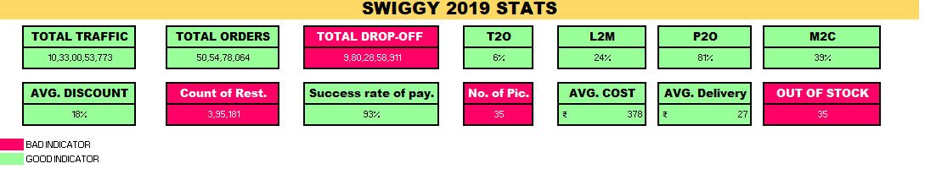

**Fig 12: Swiggy 2019 stats**

**Predictive Queries**

1. What is the journey of a customer through the Swiggy app?

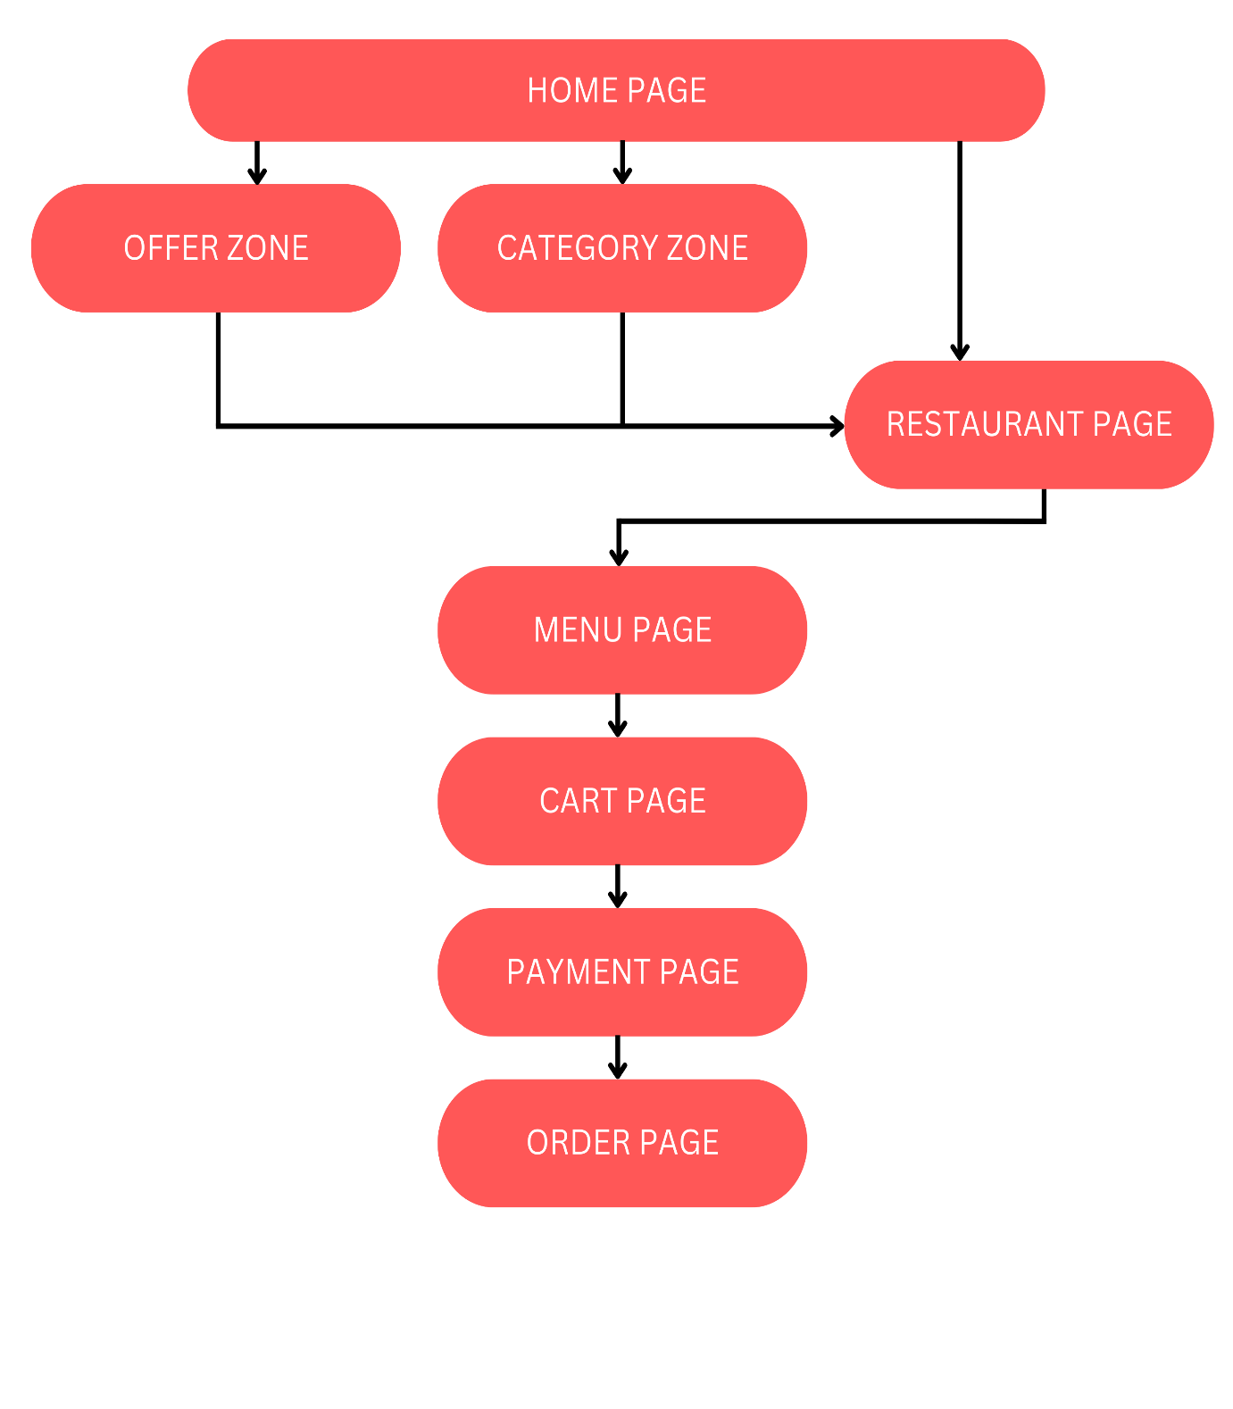

**Fig 13: Customer journey through Swiggy app**

2. Why always the order numbers are less than listing numbers?

* Exploratory Behaviour: Users often browse through listings and explore menus without necessarily placing an order.
* Variety of Options: The availability of a wide variety of listings and options may lead users to explore more choices before making a final decision, contributing to a higher number of listings.

3. How to generate more session ids?

* Marketing Campaign: Launching targeted marketing campaigns to promote the swiggy platform. Utilize various channels, such as email newsletters to reach a wide audience.
* SEO and Online Visibility: Optimizing the Swiggy website for search engines to improve online visibility. Ensure that the platform ranks well for relevant keywords, making it easier for users to discover the service.

4. What is the new strategy which can be implemented to improve smaller conversion/orders?

* Interactive and Gamified Loyalty Programs: Introducing gamification elements into the loyalty programs to make it more engaging. Customers could earn points or rewards by completing challenges, exploring new menu items, or achieving specific milestones. This interactive approach can boost customer retention and encourage smaller conversion.

5. How to improve the customer experience in Swiggy?

* Personalized Recommendations: Implementing personalized recommendation engines that suggest menu items based on customer’s previous orders and preferences. This enhances the overall user experience and encourages repeat business.
* Educational Content: Offer educational content, such as cooking tips, nutrition information, or chef profiles, to engage customers and add value beyond the basic transactions.

**Framework to be applied**

The framework which can be used is AARRR. The AARRR framework, also known as the pirate metrics, is a model that outlines the different stages of the customer lifecycle. The acronym stands for Acquisition, Activation, Retention, Revenue, and Referral.

1. **Acquisition**

*Objective*: Increase the number of users visiting the swiggy platform.

*Key Metrics*: Number of new users and User demographics.

*Strategy*: Optimize app store listings for better visibility and referral amount to be slightly increased.

1. **Activation**

*Objective*: Ensure that users have a positive first experience with the swiggy platform, leading to the initial engagement.

*Key Metrics*: Number of activated users and Conversion rates from listing to cart payment.

*Strategy*: Streamline the onboarding process for new users.

1. **Retention**

*Objective*: Encourage users to return to the swiggy platform for subsequent orders.

*Key Metrics*: RFM analysis and customer satisfaction scores.

*Strategy*: Send targeted promotions to retain users who haven’t placed an order recently.

1. **Revenue**

*Objective*: Increase the average order value and overall revenue generated by the platform.

*Key Metrics*: AOV and total revenue generated.

*Strategy*: Introduce premium services or subscription models and implement upselling and cross-selling strategies to increase order values.

1. **Referral**

*Objective*: Encourage existing users to refer new users to the swiggy platform.

*Key Metrics*: Number of referral sign ups and virality coefficient

*Strategy*: Leverage social media and word-of-mouth marketing.